# CS 255 System Design Document Template

## UML Diagrams

### UML Use Case Diagram

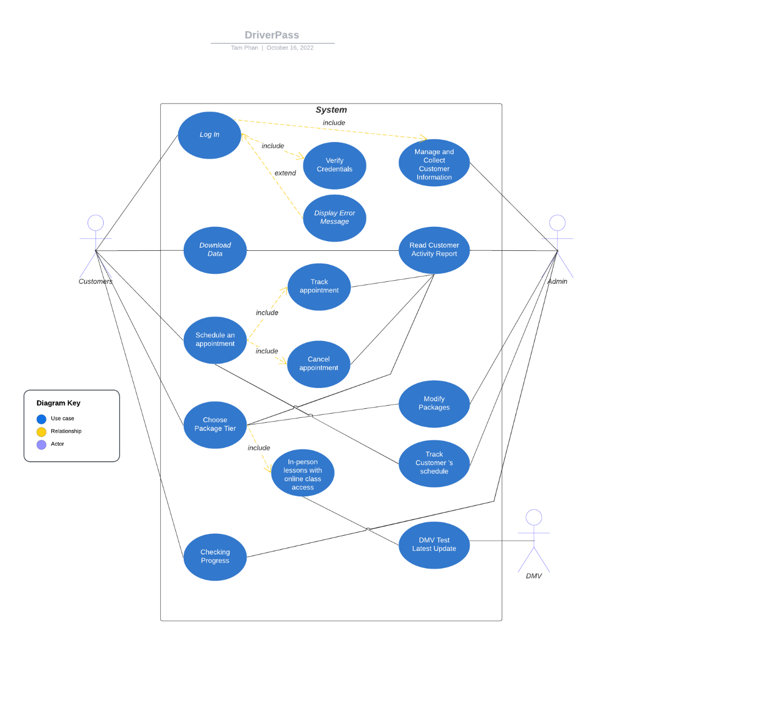

### UML Activity Diagrams

### UML Sequence Diagram

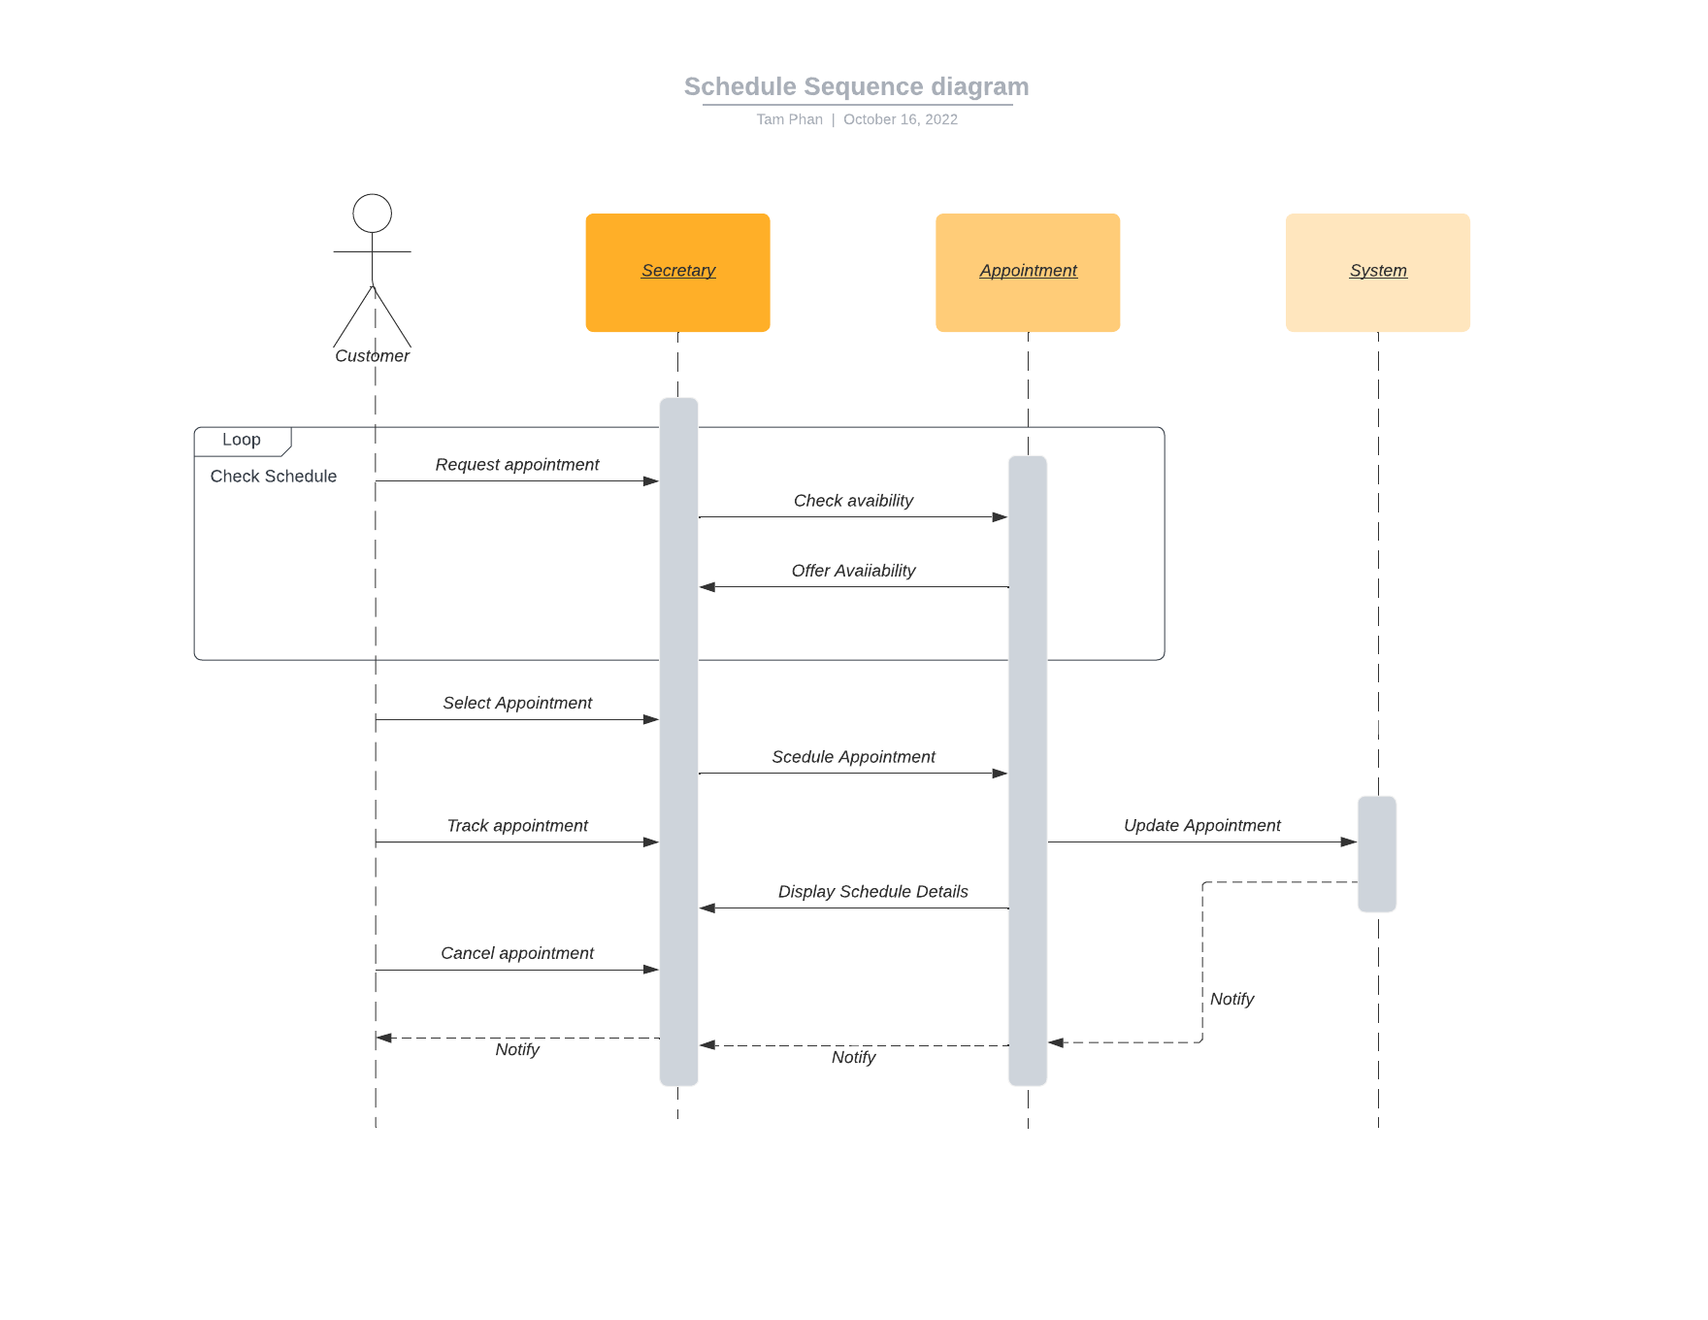

### UML Class Diagram

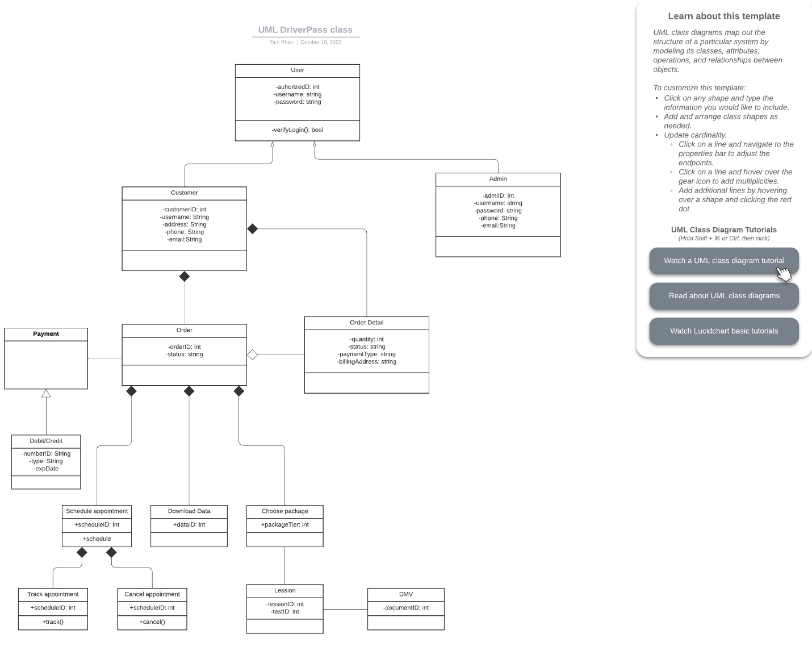

## Technical Requirements

*-System maintain a 100% stability while running*

*-System work on any operating systems with internet connection*

*-System accept payment via debit or credit card and generate billing to customer*

*-System have own dedicated database for customer and admin to access*